Name: Pranali Sonawane
Subject: MCSA
Date: 15-12-2025
Lab: Inheritance
Server 1:
Server1 Tool Active directory users and computers
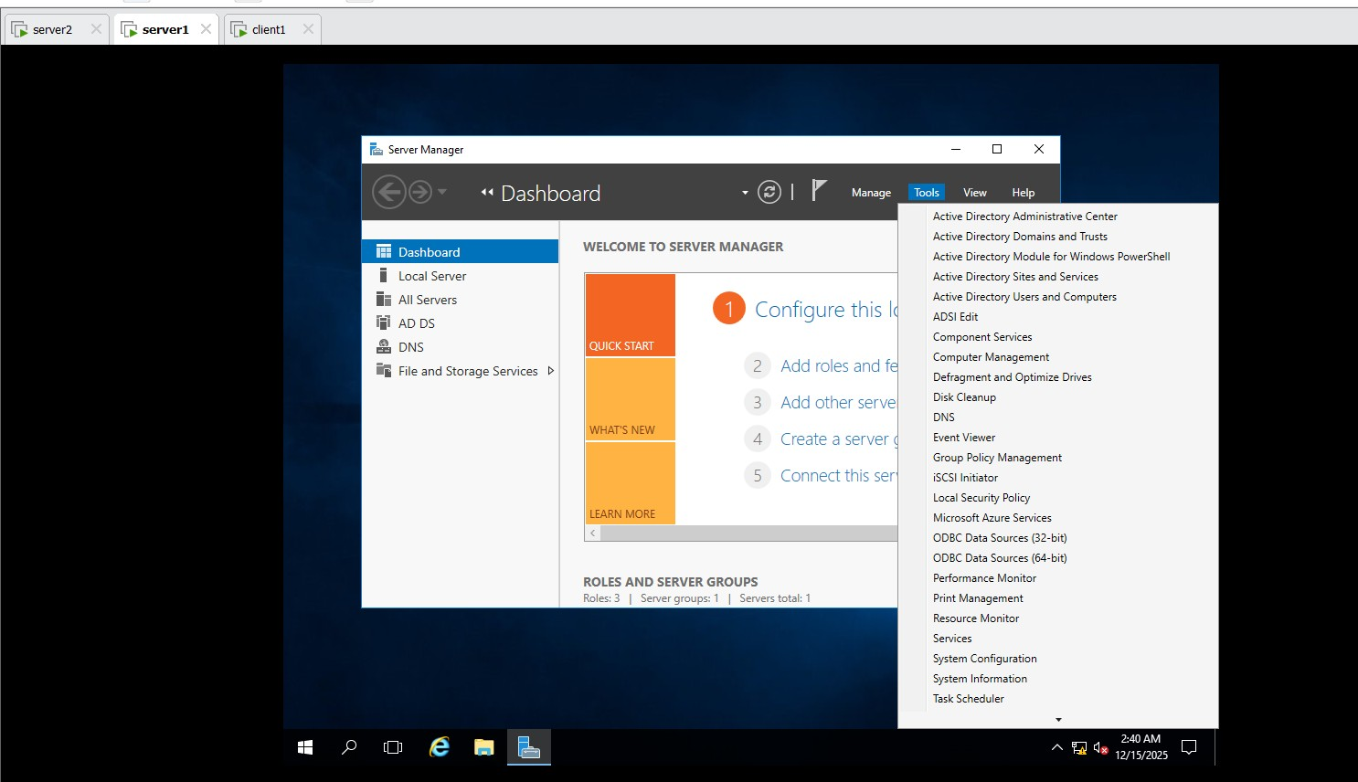
microsoft.com create organizational Unit (OU) as
RMG
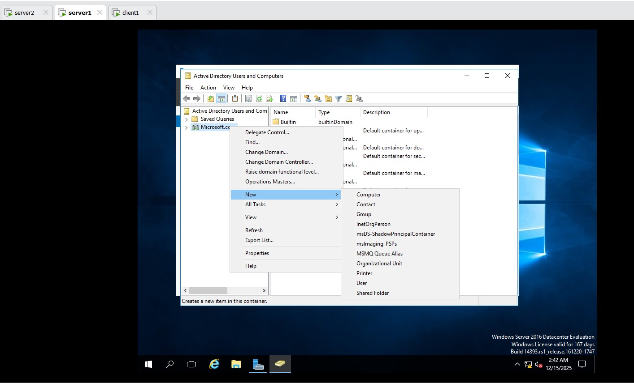
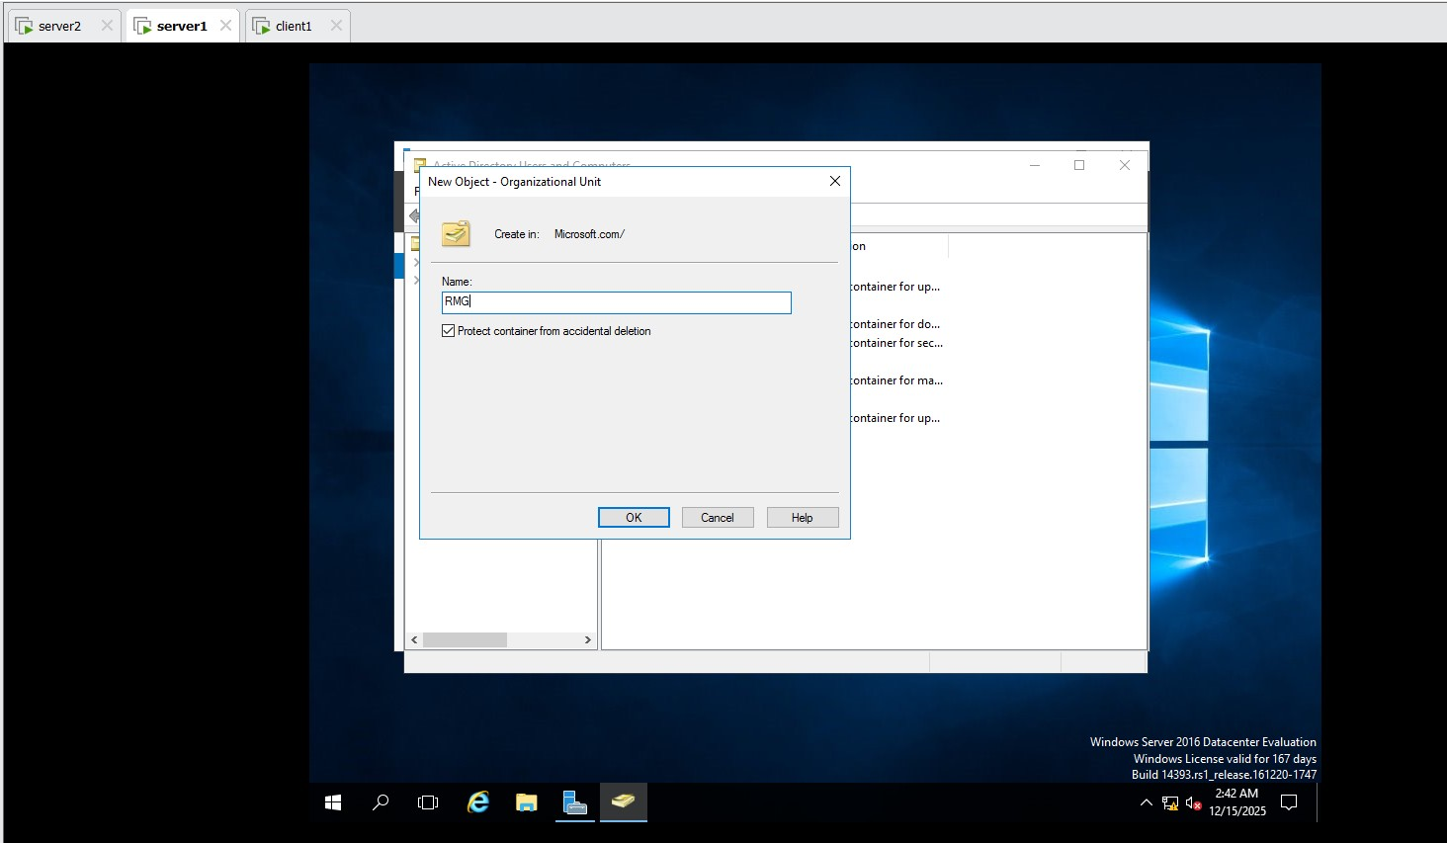
Create user in that OU as RMG1
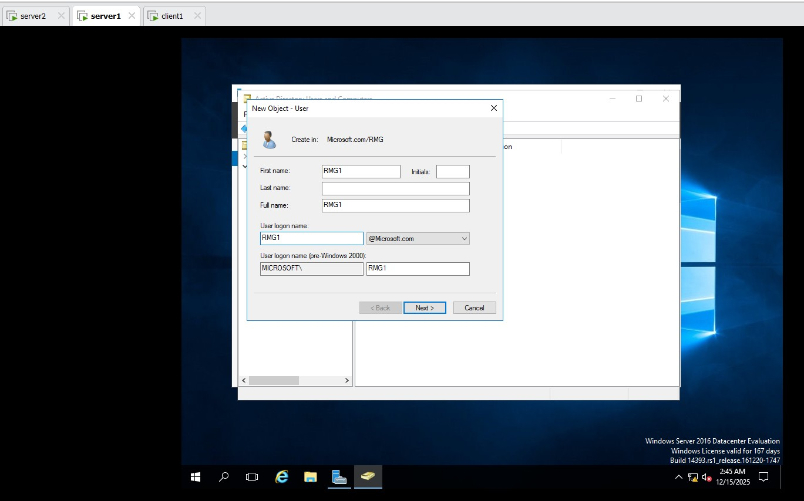
Tools group policy management Microsoft.com RMG1 click on Block Inheritance

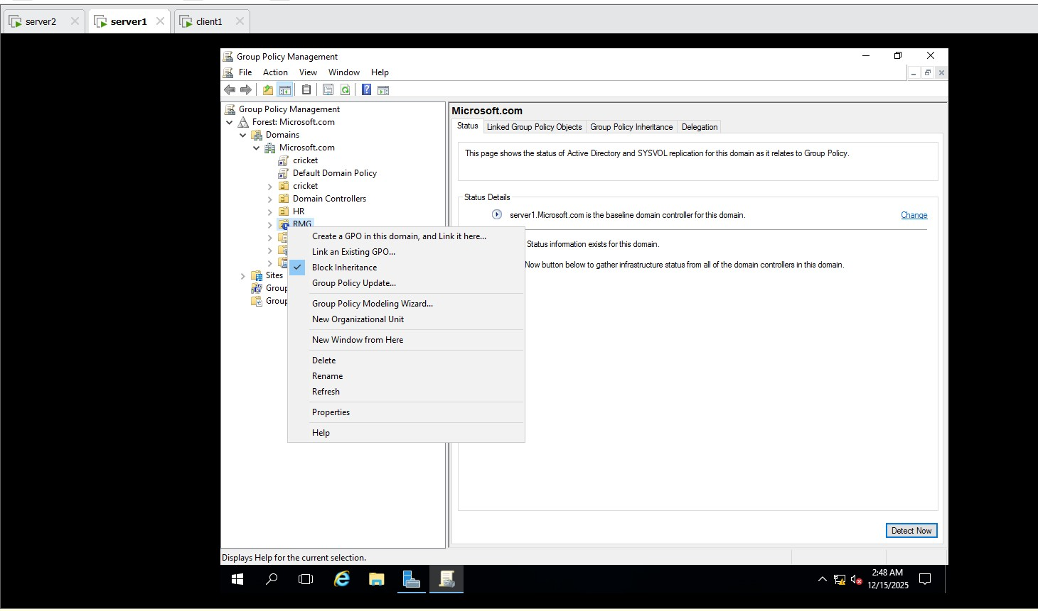
default domain policy Edit user configuration
Administrative templet policy start menu and taskbar Click on remove run menu from start menu enable the run menu from start menu apply and Ok

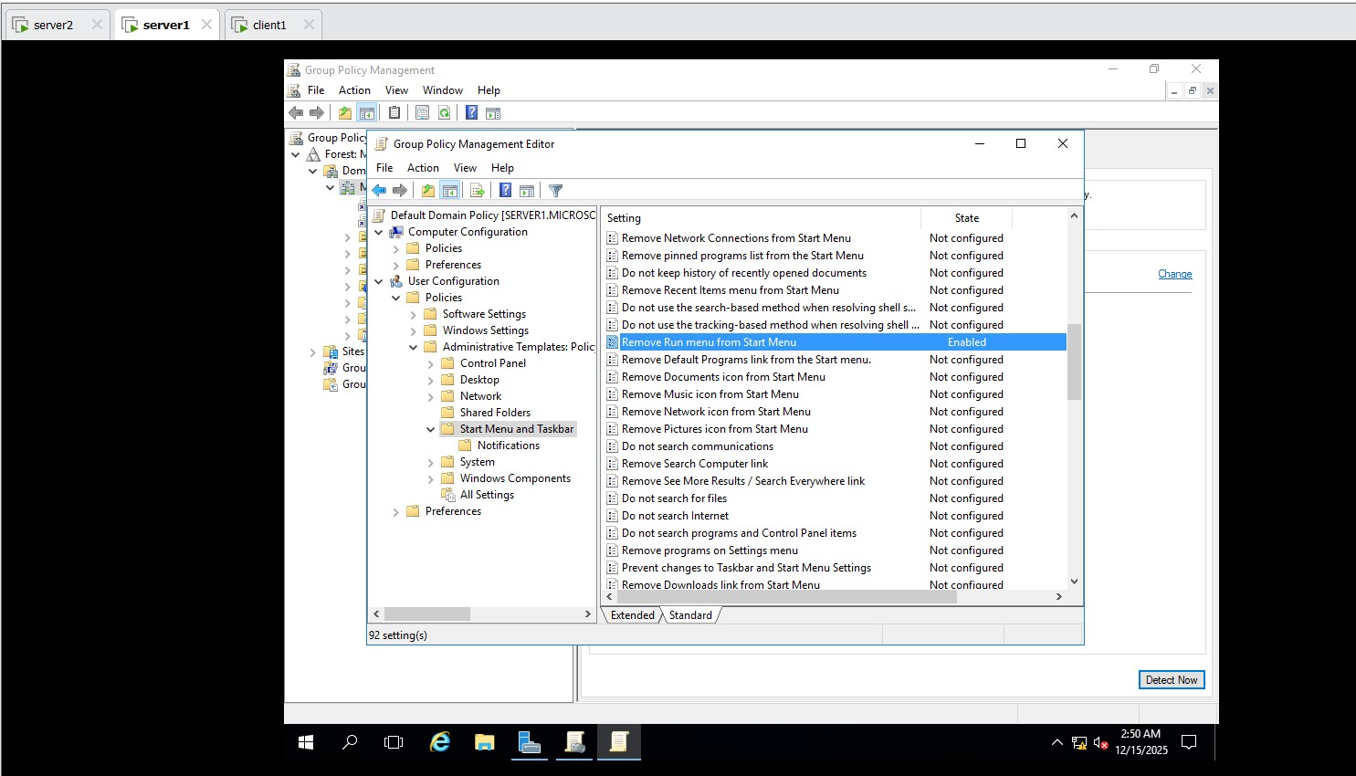

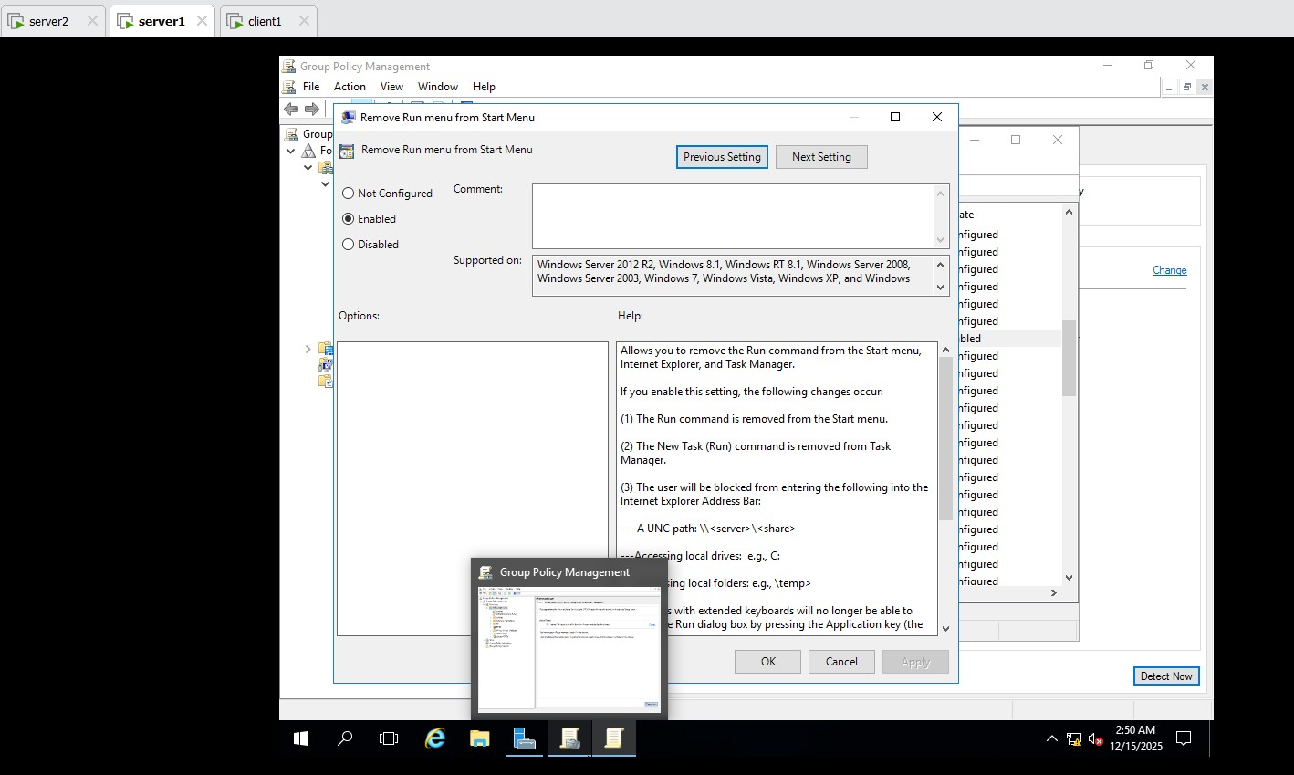

Restart the server1 after enable the policy or u can use gpupdate / force command in cmd

In Client 1 : login : Username : RMG1
Password: Password@123
When you login as RMG1 user run menu will work because we block the inheritance (the policy which apply on default domain)
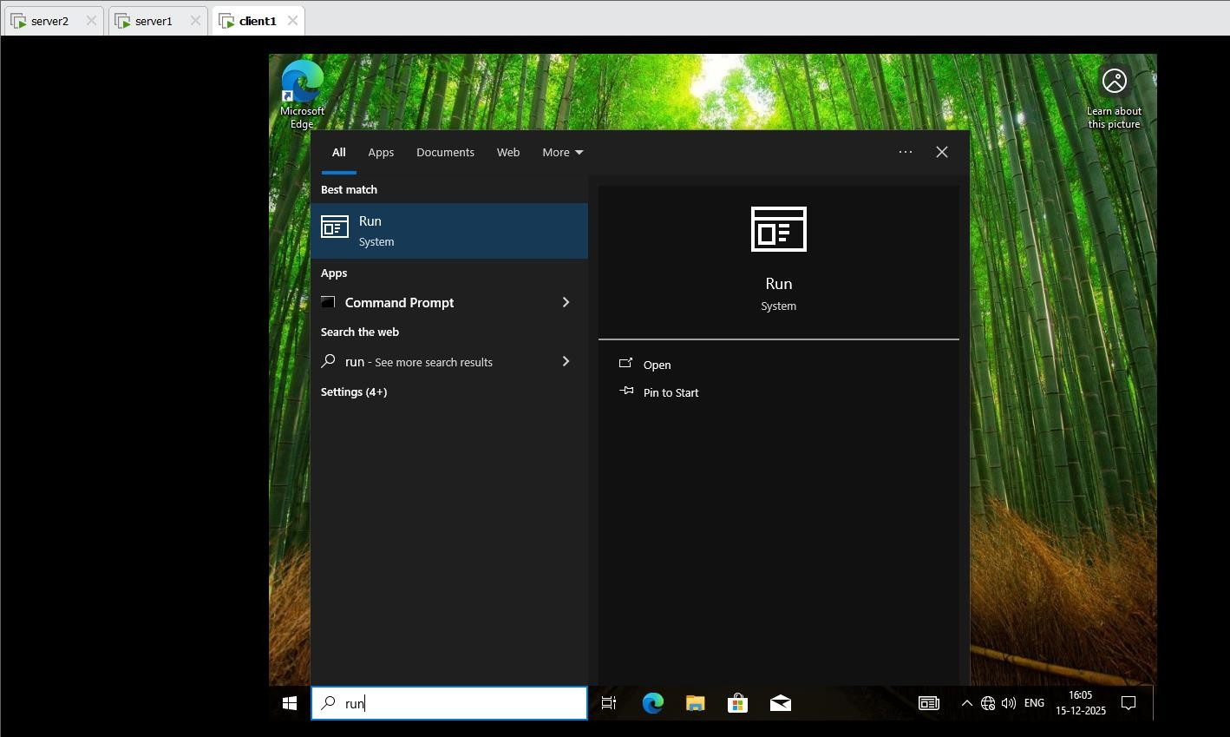

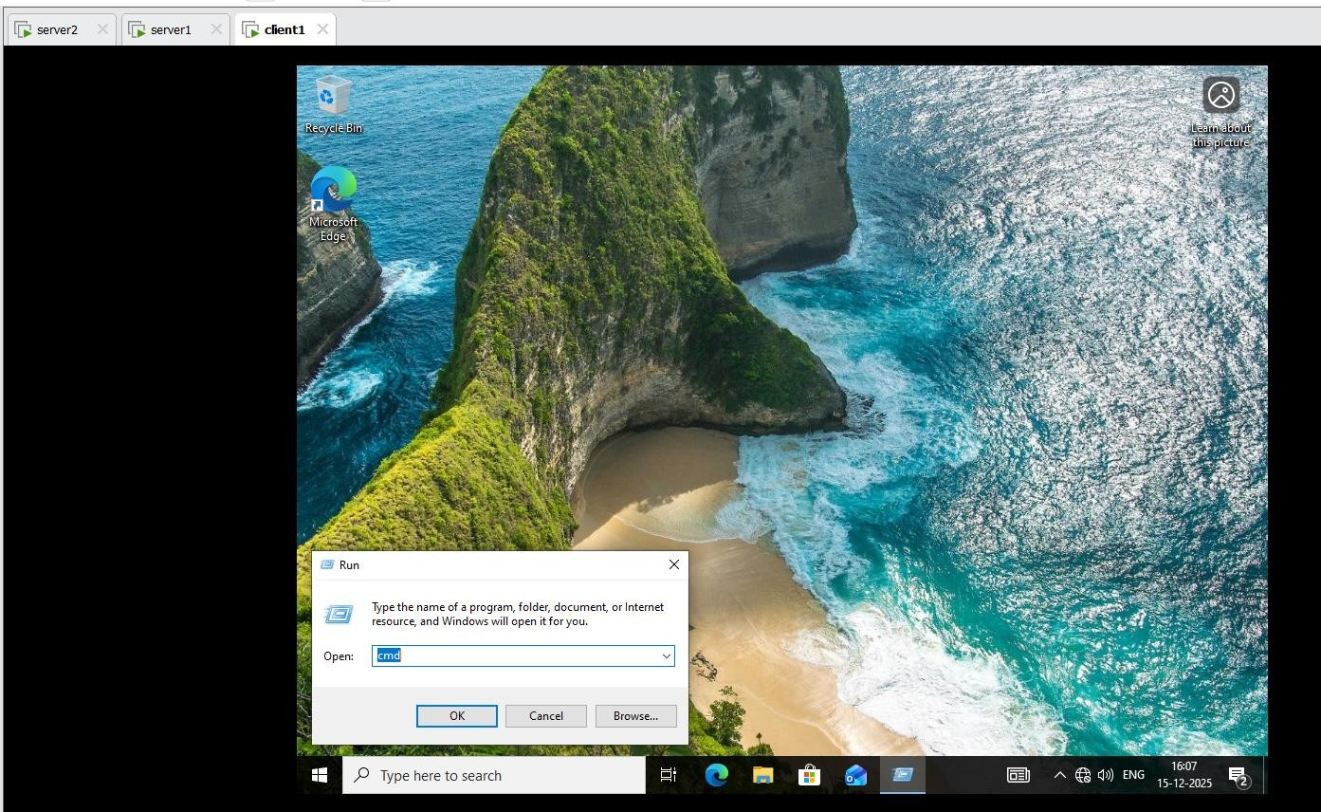
In Client 1:
Login: Username: Shiv
Password: Password@123
